**Assessment 2**

**(List & Set)**

**Email address:**

**Participant id:**

**1.** What will be the output of this code? (2 points)

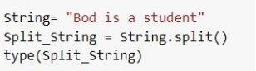

* String
* Set
* List
* Split String

**2.** What will be the output of this code? (3 points)

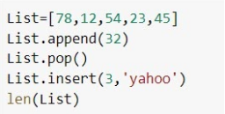

* 5
* 6
* 7
* 8

**3.** What will be the output of this code? (5 points)

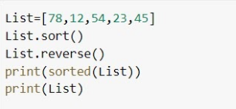

* [78, 54, 45, 23, 12] --- [12, 23, 45, 54, 78]
* [12, 23, 45, 54, 78] --- [78, 54, 45, 23, 12]
* [12, 23, 45, 54, 78] --- [12, 23, 45, 54, 78]
* [78, 54, 45, 23, 12] --- [78, 54, 45, 23, 12]

**4.** Which of these statements is/are true? (2 points)

* List is unordered & Set is unordered
* List is ordered & Set is unordered
* pop(), remove() and append() are common methods of List and Set

**5.** What will be the output of this code? (3 points)

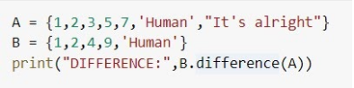

* DIFFERENCE: {9, 4}
* DIFFERENCE: {"It's alright", 3, 5, 7}
* DIFFERENCE: {1, 2, 'Human'}